**a**

POINT OF SALE & INVOICING SYSTEM - LG PACKAGING

[031 205 3424, admin@lgpackaging.co.za]

ISTN3AS MILESTONE 1

***Migyle Naidoo (223004000)***

***Sasthi Naidoo (223004483)***

***Humairaa Iyoob (223005449)***

***Yusuf Abdul Roaf (219005495)***

***Celina Chetty (224175572)***

# Contents

Requirements Specification 3

Business Area 3

Background Information 3

Client Information 3

Problem Statement 3

Logical Models 5

Context-Level Diagrams 5

Context-Level Description 6

Sales Staff 6

Manager 6

Owner 6

Warehouse Staff 6

Customer 7

Level-0 Data Flow Diagrams (DFD) 8

Level-0 Data Flow Diagram Description 9

Summary of Main Processes: 9

External Entities: 9

Entity Relationship Diagram (ERD) 10

Entity Relationship Diagram Description 11

Staff Management 11

Invoice and Sales Management 11

Customer Management 11

Product and Inventory Management 11

Inventory Adjustments and Control 11

Categorization and Reporting 12

Appendix One 13

Appendix Two 14

List of Features 14

User Stories 15

Appendix Three 16

Appendix Four 18

1. Communication and Shared Access 18

2. Design and Documentation 18

3. System Implementation and Source Code Versions 18

4. Backup and Redundancy 18

Appendix Five 19

# Requirements Specification

### Business Area

LG Packaging is a reputable Business-to-Business(B2B) packaging business that has been in operation for the past 28 years, while also accommodating individuals/consumers(B2C). The business specialises in manufacturing plastic bags in-house in addition to reselling complementary packaging products namely polystyrene cups, serviettes, plastic straws and takeaway containers. Despite being 28 years in the industry, LG Packaging heavily relies on manual processes for its fundamental operations which include stock counts, invoicing and incentive management. Although basic applications like Microsoft Word and Excel are being used for invoicing and incentives these methods remain inefficient and susceptible to errors.

The business has acknowledged the need to implement a Point of Sale and Invoicing system to improve efficiency, minimise errors and escalate overall productivity. This system will have a focus on automating inventory management, staff incentives, invoicing and producing reports to modernise operations and to eliminate manual inefficiencies.

## Background Information

### Client Information

Organisations Name: LG Packaging

Organisations Contact Details

*Physical Address:* 19 Oban Place, Congela Durban

*Telephone Number*: 031 205 3424

*E-mail Address:* [admin@lgpackaging.co.za](mailto:admin@lgpackaging.co.za)

Contact Person Details

*Name:* Linda Chetty

*Contact Number:* 082 441 5384

*E-mail Address:* [linda.chetty13@gmail.com](mailto:linda.chetty13@gmail.com)

## Problem Statement

We will develop a Point of Sale (POS) and Invoicing System customised for LG Packaging. Currently, LG Packaging is facing inefficiencies and manual work delays in its sales processing, inventory management and incentives management. This leads to loss in productivity, delayed decision making and increased operational costs. By automating the point-of-sale system, the business can make customer transactions faster, avoid billing errors and deliver a smoother, more enjoyable experience. At the same time, implementing real-time inventory management will give the company better control over stock, help predict demands and trends, cut down waste and maintain healthy inventory levels and improving the incentives management by automating and tracking incentives assigned to employees will lower the possibility of calculation errors. This improved system will not only make daily operations more efficient but also support the company’s long-term goals of scaling up.

The inefficiencies or current challenges include:

* **Manual Inventory Management:** Acquisition tracking and stock counts are carried out by hand. This results in errors and improper handling of both raw materials and final products.
* **Incentives Calculation Errors:** There is an increased risk of human errors and employee dissatisfaction due to incentives being manually calculated. Manual calculations increase the likelihood of inaccuracies, delays and inconsistencies, making the process inefficient and prone to disputes.
* **Inefficient Invoicing Process:** Generating invoices, tracking payments and updating financial records are done manually. This results in delayed transactions and the administrative duties increase.
* **Lack of Data Security:** There is a chance of data loss, manipulation and security breaches due to many physical copies of records.
* **Time-Consuming Processes:** Manual record-keeping creates unnecessary delays in overall operations. Because of this, LG Packaging finds it challenging to grow efficiently.
* **Difficulty Generating Reports**: Since everything is documented manually, it is time-consuming to develop reports that aid business intelligence. Reports may also have human errors and advanced data analysis is limited.

The new IT system will streamline and automate the sales process, reducing manual effort and errors. When a customer places an order, the sales staff processes it through the system, which automatically generates an invoice linked to the respective staff member. The system then updates inventory in real time, ensuring stock levels reflect the latest sales. Additionally, all sales data is logged, allowing for seamless tracking of transactions. This integration enhances efficiency, improves order accuracy, and provides valuable data for invoicing, inventory management, and incentive calculations. The new IT system will automate four areas:

* 1. I**nventory Management:**

1. Real-time tracking of sales, stock updates.
2. Enhances warehouse organisation and lessens stock counting errors.
   1. **Reports:**
3. Generate, store and manage reports on different business operations.
4. Provide insights into sales trends, stock levels, staff performance and financial summaries, allowing management to make informed decisions.
   1. **Incentives Management:**
5. Automatically calculates sales staff incentives based on predefined criteria such as total sales amount, quantity of products sold, or the number of invoices processed.
6. Generates incentive reports and maintains records of sales performance to ensure accurate and transparent commission calculations.
   1. **Invoicing:**
7. Updates financial information, tracks payments, creates and prints invoices automatically.
8. Enhances cash flow management and eliminates billing errors.

# Logical Models

## Context-Level Diagrams

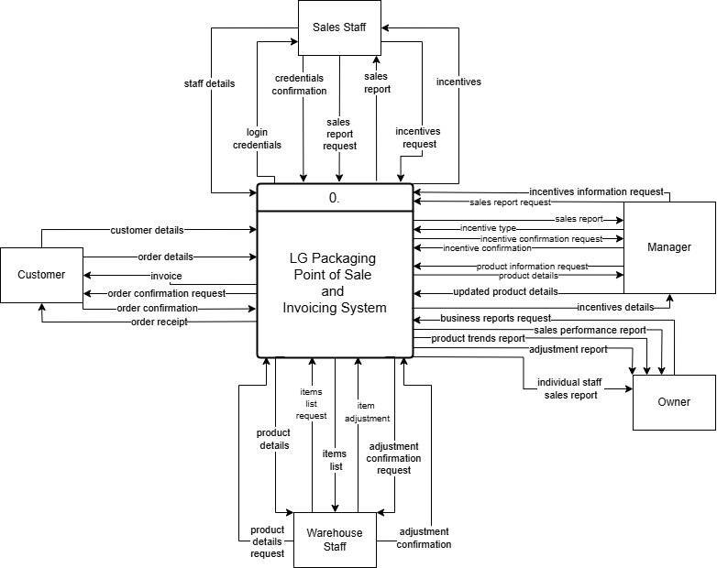

# Context-Level Description

The LG Packaging POS and Invoicing System sits at the center of operations, interacting with five key external entities:

### Sales Staff

Sales staff use the system to:  
- Log in with their credentials, which the system verifies for security.  
- View sales reports and incentive details based on the invoices they generate.  
- The system simplifies their workflow by eliminating manual incentive tracking and sales summaries, enabling them to focus on customer service.

Significance of data flows:  
- Enables secure login and access.  
- Supports real-time performance feedback through automatic incentive calculations and reporting.

### Manager

The manager interacts with the system primarily to:  
- Create and confirm incentives by submitting an incentive type.  
- Access product details and sales reports, allowing them to make informed business decisions and monitor staff performance.

Significance of data flows:  
- Promotes informed decision-making through real-time data.  
- Reduces administrative effort by automating incentive tracking and product updates.

### Owner

The owner receives:  
- Business reports, sales performance, and adjustment reports, giving a high-level overview of company operations.  
- They can also view individual staff sales reports and business sale reports making it easier to evaluate both business and individual performance.

Significance of data flows:  
- Provides critical insights for strategic planning.  
- Ensures transparency in sales and staff productivity.

### Warehouse Staff

Warehouse staff interact with the system to:  
- Submit item adjustments and receive confirmation.  
- Request item lists and add/update item details as stock changes occur.

Significance of data flows:  
- Keeps inventory levels accurate and up to date.  
- Ensures the sales and invoicing system reflects real-time stock availability.

### Customer

Customers provide:  
- Order and personal details which are processed by the system to generate invoices and order confirmations.  
- In return, they receive an order receipt/invoice and confirmation, ensuring a smooth transaction experience.

Significance of data flows:  
- Streamlines the customer checkout process.  
- Provides formal proof of purchase and supports better customer service.

## Level-0 Data Flow Diagrams (DFD)

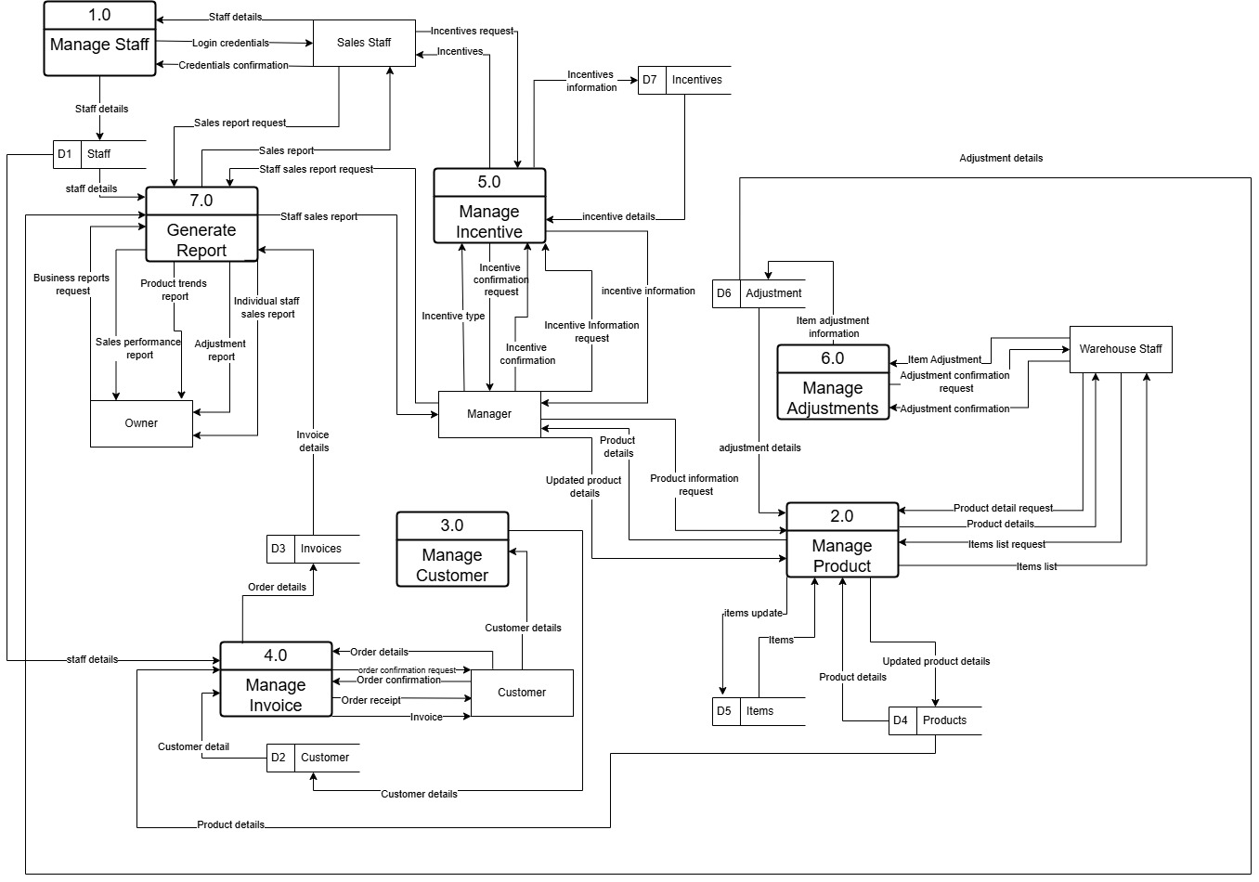

# Level-0 Data Flow Diagram Description

The Level 0 Data Flow Diagram (DFD) for the LG Packaging Point of Sale and Invoicing System breaks down the system into 7 major processes and shows how data flows between them and the external entities. This diagram provides a complete overview of how data is processed within the system, ensuring smooth operations and proper communication among all users and system components. It illustrates a clear, modular approach to managing core business functions.

### Summary of Main Processes:

* **Manage Staff (1.0):** Handles login and staff detail management. Sends staff credentials to validate and receive confirmation.
* **Manage Product (2.0):** Maintains product data. It processes product detail updates, requests from warehouse staff and forwards updates to other processes.
* **Manage Customer (3.0):** Maintains customer records and processes customer details related to orders and invoices.
* **Manage Invoice (4.0):** Creates and manages invoices based on customer orders and staff involvement. Sends invoice information to various processes.
* **Manage Incentive (5.0):** Oversees incentive details for staff. It communicates with managers for incentive configuration and responds to staff requests.
* **Manage Adjustments (6.0):** Manages item adjustments, particularly by warehouse staff and updates item details accordingly.
* **Generate Report (7.0):** Gathers sales, product trends and performance data to generate various reports for the owner and manager.

### External Entities:

* **Customer:** Places orders, receives invoices and confirmations.
* **Sales Staff:** Requests sales reports and incentives, logs in via staff credentials.
* **Warehouse Staff:** Requests product and item info, updates item adjustments, and confirms changes.
* **Manager:** Manages incentives and product updates.
* **Owner:** Requests various business reports including staff performance and product trends.

## Entity Relationship Diagram (ERD)

# Entity Relationship Diagram Description

This Entity Relationship Diagram (ERD) represents a comprehensive business management system designed to handle sales, inventory control, employee tracking, customer management, and performance-based incentives.

### Staff Management

The Staff entity holds essential details about employees, including their login credentials, roles, and contact information. Staff members are responsible for creating invoices, managing inventory adjustments, and qualifying for performance incentives. These incentives are tracked with attributes such as the date awarded, amount, and type.  
Additionally, staff members are linked to adjustments and invoices, establishing accountability for sales and stock changes. Each staff member has a unique staff_ID, and their activity in the system supports performance evaluation.

### Invoice and Sales Management

The Invoice entity tracks sales transactions. Each invoice is linked to a specific Customer and is issued by a designated Staff member. Invoices include multiple line items, managed through the Invoice_Items table, which records the products sold, their quantities, and prices. This ensures detailed tracking of each item in every sale.  
The Invoice also includes attributes such as date, total amount, payment method, payment due date, and status. The use of a composite key in Invoice_Items ensures traceability of specific items sold within each invoice.

### Customer Management

The Customers table stores key customer information, including addresses and contact details. A single customer can have multiple invoices, enabling the system to analyse purchase history and behaviour over time. This also supports the application of customer-specific discounts.  
Each customer may be enrolled in a loyalty program, tracked by the Loyalty table, which records points earned and expiry dates. This structure encourages customer retention and repeat business by offering rewards based on purchase activity.

### Product and Inventory Management

The Product entity contains details about each product, such as its name, description, and price. Products are grouped into Categories, which assist with organisation and reporting. The Items entity tracks inventory levels for each product, including quantities available.  
Products are uniquely identified by a product ID and contain attributes like cost price, selling price, size, colour, quantity on hand, and reorder levels. Each item in inventory has a barcode number that links it to a specific product, allowing for individual item tracking and precise stock control.

### Inventory Adjustments and Control

The Adjustments table ensures inventory accuracy by recording stock changes due to events like damage or defects. Each adjustment is linked to a specific Staff member who performed it and the affected Item, along with details like adjustment type and date.  
This ensures full traceability of inventory movements by documenting when, why, and by whom changes were made to stock levels.

### Categorisation and Reporting

The Category table organises products into meaningful groups to simplify reporting and inventory analysis. This structure supports data-driven decision-making regarding product performance and stock management strategies.  
Categories include a name and description, and each product is assigned to a single category, which helps streamline product filtering, sales reporting, and replenishment planning.

# Appendix One

|  |  |  |  |  |
| --- | --- | --- | --- | --- |
| **No.** | **Student Number** | **Name & Surname** | **% of Estimated Contribution to M1** | **Signature** |
| 1 | 223004000 | Migyle Naidoo | 20 |  |
| 2 | 223004483 | Sasthi Naidoo | 20 |  |
| 3 | 223005449 | Humairaa Iyoob | 20 |  |
| 4 | 219005495 | Yusuf Abdul Roaf | 20 |  |
| 5 | 224175572 | Celina Chetty | 20 |  |

# Appendix Two

## List of Features

|  |  |  |  |
| --- | --- | --- | --- |
| **Feature Description** | **User Profile** | **Priority (Low/Medium/High)** | **No. of Weeks/Days** |
| Log into Manager Dashboard | Manager | High | 1 day |
| Log into Staff Dashboard | Sales Staff | High | 1 day |
| Create Invoice | Sales Staff | High | 4 days |
| Update Product Details | Manager | Medium | 1 day |
| Search Product | Manager | Medium | 1 day |
| Small view of product image | Sales Staff | Low | 1 day |
| Add New Product | Manager | High | 1 day |
| View Low Stock Alerts | Manager | High | 3 days |
| Make Stock Adjustments | Warehouse Staff | High | 2 days |
| Create Customer Account | Sales Staff | High | 2 days |
| Create Staff Account | Manager | High | 2 days |
| Create Incentives | Manager | High | 3 days |
| View Incentives | Sale Staff | High | 2 days |
| Search Staff | Manager | Medium | 1 day |
| Generate Business Reports | Owner | Medium | 5 days |
| Print Business Reports | Manager | Low | 2 days |
| Print Invoice | Sales Staff | Low | 1 day |

## User Stories

“As a sales staff member, I want to create an invoice to record the products that a customer is requesting to buy.”

“As a manager, I want to update product details so that they reflect new product descriptions or correct previous errors in product details.”

“As a manager, I want to view stock alerts so that I can review stock levels and send alerts to the factory and warehouse staff to start and prepare for manufacturing of new stock.”

“As a warehouse staff member, I want to make stock adjustments to reflect stock that has been discarded due to defects or damage so that quantity of stock available can be accurate.”

“As an owner, I want to generate business reports so that I can make informed decisions on which products require more stock and which staff members are performing well or underperforming.”

# Appendix Three

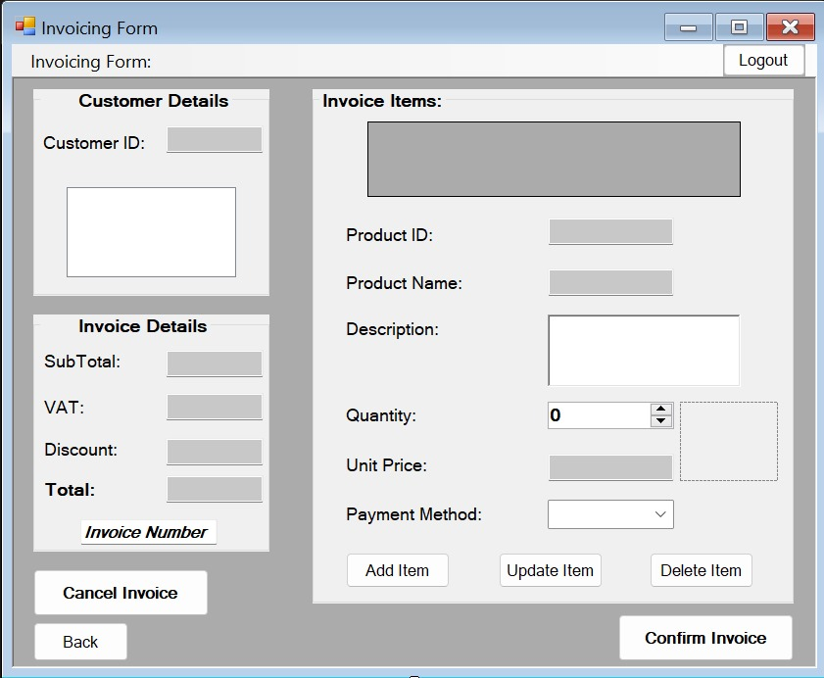

# Appendix Four

To ensure smooth collaboration, maintain consistency, and keep track of all system documents throughout the system development lifecycle, the following version control approach will be used by the team:

# 1. Communication and Shared Access

* A dedicated group email address will be used for all project-related communication, coordination, and platform access (e.g., Google Drive, GitHub).
* Access to shared folders and platforms will be managed via this account to ensure consistent availability and centralised control.

# 2. Design and Documentation

* Google Drive will be used to store all non-code assets such as:
  + Diagram models (DFDs, ERDs, Use Case Diagrams, etc.)
  + Project documentation (requirements specification, business case, etc.)
  + Meeting notes and feedback documents.
* Google Docs will be used for collaborative editing and real-time contributions.

# 3. System Implementation and Source Code Versions

* Once development begins, GitHub will be used for version control of the system's source code.
  + A private GitHub repository will be created and shared with all group members via the group email.
  + Branching strategies (e.g., main, dev) will be used to manage work on different parts of the system.
  + Commits will be made regularly with descriptive messages to track changes effectively.
  + Pull requests and code reviews will be used to ensure quality and collaborative approval before merging into the main branch.

# 4. Backup and Redundancy

* All-important files will be backed up regularly by downloading copies of Drive folders and GitHub repositories.
* Manual backups will be scheduled weekly, especially during the system implementation phase.

# Appendix Five

|  |  |  |
| --- | --- | --- |
| **Name of the AI Tool** | **Details of what it was used for and how it was used (this column could consist of multiple lines)** | **Percentage approximation of the role played by AI for this aspect of the M1** |
| Grammarly | -Grammatical error fixes  -Punctuation errors | 5% |
| ChatGPT | -Sentence rephrasing | 10% |